LIVE WEATHER FORECASTING

# ABSTRACT

Weather forecasting has undergone significant advancements over the years, transitioning from traditional methods to modern, data-driven approaches. The integration of cutting-edge technologies, such as artificial intelligence (AI) and machine learning, has revolutionized the accuracy and timeliness of weather predictions. These technologies allow meteorologists to analyze vast amounts of data from satellites, weather stations, and other sources in real-time, providing more precise forecasts for short-term and long-term weather conditions.

One of the pivotal aspects of live weather forecasting is the utilization of high-resolution weather models. These models simulate the Earth's atmosphere, incorporating complex physical processes and variables to generate forecasts. Advanced computational techniques enable meteorologists to run these models with increased resolution and speed, capturing intricate weather patterns and phenomena more accurately. As a result, forecasts can be tailored to specific regions and timeframes, enhancing their relevance and reliability for both professionals and the general public.

Furthermore, the accessibility of live weather data and forecasts has improved significantly with the proliferation of digital platforms and mobile applications. Real-time updates, interactive maps, and personalized alerts empower individuals to make informed decisions based on the latest weather information. Whether planning daily activities, managing agricultural operations, or preparing for severe weather events, the availability of live weather forecasting tools ensures that users are better equipped to adapt and respond to changing atmospheric conditions effectively.

## TABLE OF CONTENTS

**S.No Title Page No**

**ABSTRACT iii**

**LIST OF FIGURES vi**

**LIST OF ANCRONYMS AND ABBREVATIONS vii**

1. **INTRODUCTION 7**
   1. Problem Statement **7**
   2. Project Domain **9**
   3. Scope of the Project **10**
2. **PROJECT DESCRIPTION 11**
   1. Existing System **11**
   2. Literature Review **12**
   3. Issues in Existing System **14**
   4. Software Requirements **15**
3. **DESIGN 16**
   1. Proposed System **16**
   2. Architecture Diagram **17**
   3. Design Phase **18**
   4. Use Case Diagram **1****8**
   5. Data Flow Diagram **1****9**
   6. Sequence Diagram **20**
   7. Module Description **21**
      1. Data Preprocessing Module **23**
      2. Data Collection Module **24**
      3. Alerting Module **25**
      4. Administrative Module **26**

1. **IMPLEMENTATION 27**

**5 RESULTS AND DISCUSSION 33**

**5.1** Observations during Implementation of the Model **33**

**6 CONCLUSION AND FUTURE ENHANCEMENT 37**

**6.1** Conclusion **37**

**6.2** Future Enhancement **37**

**REFERENCES** **39**

## LIST OF FIGURES

## S.NO NAME PAGE.NO

## Architecture Diagram 17

## 3.4 Use Case Diagram 18

**3.5 Data Flow Diagram 19**

## Sequence Diagram 20

**3.7 Module Description 21**

## LIST OF ANCRONYMS AND ABBREVATIONS

## DBMS - DATABASE MANAGEMENT SYSTEM ML - MACHINE LEARNING

**SQL - STRUCTURED QUERY LANGUAGE DDL - DATA DEFINITION LANGUAGE**

**DML - DATA MANIPULATION LANGUAGE**

## UI - USER INTERFACE

## UX - USER EXPERIENCE

**Chapter 1**

**INTRODUCTION**

Live weather forecasting is an indispensable tool that provides real-time updates on atmospheric conditions, enabling individuals and organizations to make informed decisions based on current and upcoming weather patterns. Utilizing advanced meteorological technologies, these forecasts offer a detailed overview of temperature fluctuations, precipitation probabilities, wind speeds, and atmospheric pressure changes. By continuously monitoring atmospheric data from satellites, weather stations, and radar systems, meteorologists can generate accurate and timely predictions that help mitigate risks associated with severe weather events, optimize agricultural practices, and support various industries like aviation, shipping, and construction.

## Objective of the Project

## The objective of the project is to develop a live weather forecasting system that provides real-time weather updates to users. It aims to utilize advanced meteorological data and machine learning algorithms to predict weather conditions accurately. The system will offer detailed forecasts, including temperature, humidity, wind speed, and precipitation, for specific locations. By leveraging cloud computing and data analytics, the project seeks to deliver timely and reliable weather information to help individuals and organizations make informed decisions. Ultimately, the goal is to enhance safety, planning, and preparedness for weather-related events.

## Problem Statement

Live weather forecasting is crucial for providing timely and accurate information to the public, businesses, and emergency services to make informed decisions about their activities and safety. The primary challenge lies in predicting rapidly changing weather conditions in real-time, which requires advanced data processing, modelling, and interpretation techniques. Additionally, integrating various sources of data, such as satellite imagery, radar data, and ground observations, in a cohesive and timely manner is essential for generating reliable forecasts. Despite advancements in technology, achieving high precision and reliability in live weather forecasting remains a complex problem due to the inherent uncertainties and complexities associated with atmospheric processes.

To address this problem, there is a need for continuous innovation in meteorological models, data collection methods, and computational techniques to improve the accuracy and timeliness of live weather forecasting. This involves developing sophisticated algorithms and machine learning models that can analyse large volumes of data quickly and identify patterns and trends in weather patterns. Furthermore, enhancing the collaboration and communication between meteorologists, researchers, and data scientists can facilitate the development of more robust forecasting systems. By overcoming these challenges, we can enhance the reliability of live weather forecasts, thereby assisting individuals and organizations in making informed decisions and mitigating the impact of adverse weather events.

#### Key challenges in addressing this problem include:

1. **Data Accuracy and Availability**: Ensuring real-time access to accurate and comprehensive weather data from various sources is crucial. Inaccurate or incomplete data can lead to incorrect forecasts, affecting public safety and preparedness.
2. **Computational Power and Speed:** Weather forecasting requires complex mathematical models and simulations that demand significant computational power. Ensuring that the systems can process and analyse data quickly enough to provide timely forecasts is a constant challenge.
3. **Modelling Complexity:** Weather systems are inherently chaotic and influenced by numerous variables, making them challenging to model accurately. Improving the sophistication and accuracy of forecasting models to account for these complexities is an ongoing endeavour.
4. **Communication and Interpretation:** Translating complex weather data and forecasts into understandable and actionable information for the public, emergency services, and other stakeholders is essential. Effective communication strategies and tools are needed to ensure that the information is clear, accessible, and timely

## Project Domain – ML

Live weather forecasting is an essential aspect of meteorology, providing timely and accurate information to support various sectors such as agriculture, aviation, and disaster management. Machine Learning (ML) has emerged as a powerful tool in enhancing the accuracy and reliability of weather predictions. By analysing vast amounts of historical and real-time weather data, ML models can identify patterns, trends, and correlations that traditional forecasting methods might overlook. This enables meteorologists to generate more precise forecasts, taking into account a wide range of variables such as temperature, humidity, wind speed, and atmospheric pressure.

Implementing ML for live weather forecasting involves the development and training of predictive models using algorithms like regression, neural networks, and decision trees. These models can assimilate data from satellites, weather stations, radar systems, and other sources to generate forecasts with improved spatial and temporal resolution. Advanced ML techniques, such as ensemble learning and deep learning, further enhance the predictive accuracy by enabling the models to learn complex relationships and non-linear interactions within the atmospheric system. By continuously updating and refining these ML models with new data, meteorologists can provide more reliable and timely weather forecasts, helping individuals and organizations make informed decisions and mitigate the impact of severe weather events.

## Scope of the Project

The primary scope of this project is to develop a real-time weather forecasting system that provides accurate and up-to-date weather information to users. The system aims to collect data from various meteorological sources, including satellites, weather stations, and other environmental sensors. This data will be processed and analyzed using advanced algorithms to generate precise weather forecasts for different regions.

Secondly, the project will focus on creating an intuitive user interface that allows users to easily access and interpret the weather information. The interface will feature interactive maps, charts, and graphs, enabling users to view current conditions, forecasts, and weather alerts for their location or any selected area.

Furthermore, the system will incorporate machine learning techniques to improve the accuracy of its predictions over time. By continuously learning from new data and feedback, the forecasting model will adapt and refine its predictions, ensuring that users receive the most reliable and timely weather information.

Lastly, the project will emphasize scalability and reliability to accommodate a growing number of users and handle high traffic loads during peak times. The infrastructure will be designed with robustness in mind, ensuring uninterrupted service and quick response times, even under heavy usage or adverse weather conditions.

## Chapter 2

## PROJECT DESCRIPTION

## Existing System

The existing system for live weather forecasting relies heavily on a combination of ground-based observation stations, satellite imagery, radar systems, and computer models. These elements work together to provide accurate and timely weather forecasts for various regions. Ground-based observation stations collect data on temperature, humidity, wind speed, and other atmospheric conditions at specific locations. Satellite imagery provides a broader view of weather patterns, including cloud cover, storm systems, and atmospheric disturbances. Radar systems help detect precipitation, such as rain or snow, and track the movement and intensity of storms.

Computer models play a crucial role in weather forecasting by simulating the behaviour of the atmosphere based on the collected data. These models use complex mathematical equations to predict future weather conditions, taking into account various factors like air pressure, temperature gradients, and wind patterns. Meteorologists analyse the output from these models along with observational data to generate forecasts that inform the public and aid in decision-making for sectors like agriculture, transportation, and emergency management.

Despite advancements in technology, the existing system faces challenges in accurately predicting extreme weather events, such as hurricanes, tornadoes, and flash floods. These events can be highly unpredictable and require specialized forecasting techniques and tools. Additionally, the accuracy of weather forecasts can be influenced by factors like data quality, model limitations, and rapid changes in atmospheric conditions. Continuous research and development are essential to improving the capabilities of the existing system and enhancing the accuracy and reliability of live weather forecasting

## Literature Review

|  |  |  |  |  |
| --- | --- | --- | --- | --- |
| **S.NO** | **TITLE** | **AUTHOR** | **METHODOLOGY** | **TECHNICAL GAP** |
| 1. | **Advancements in Weather Forecasting Technologies** | Smith et al. | Comparative analysis of traditional and modern forecasting methods | Limited integration of AI and machine learning in forecasting systems |
| **2** | **Satellite Data Assimilation in Weather Prediction** | Johnson & Lee | Study of satellite data assimilation techniques and their impact | Challenges in integrating diverse satellite data sources |
| 3 | **Machine Learning for Short-term Weather Forecasting** | Gupta & Kumar | Application of machine learning algorithms for short-term weather prediction | Need for robust feature selection and model interpretability |
|  |  |  |  |  |

|  |  |  |  |  |
| --- | --- | --- | --- | --- |
| **4.** | **Enhancements in Radar Technology for Precipitation Forecasting** | Williams et al. | Evaluation of advanced radar technologies and their effectiveness. | Inaccuracies in measuring low-intensity precipitation |
| 5. | **Improving Numerical Weather Prediction Models** | Brown & Clark | Enhancement of numerical weather prediction models and their accuracy | Computational inefficiencies and data assimilation challenges. |

**2.3 Issues in Existing System:**

**1.Communication Challenges:**

Communicating weather forecasts and warnings effectively to the public is a critical part of the forecasting process. However, it can be challenging to convey complex weather information in a way that is easily understood and acted upon, especially in situations where there is uncertainty or conflicting information.

**2.Technical Limitations:**

Weather forecasting systems rely on complex algorithms and large amounts of data, which can put a strain on computing resources and network infrastructure. Technical limitations can affect the speed, accuracy, and reliability of forecasts, especially during peak usage times or in remote or underserved areas.

**3.Climate Change:**

Climate change is causing shifts in weather patterns and increasing the frequency and severity of extreme weather events, such as hurricanes, heatwaves, and floods. This presents new challenges for weather forecasting systems, which must adapt to changing conditions and provide more accurate and timely warnings to protect lives and property.

**4. Data Quality and Consistency:**

The accuracy and consistency of weather forecasts depend on the quality and availability of observational data. However, there are still gaps and inconsistencies in the data, which can affect the reliability and accuracy of forecasts. Improving the quality and consistency of observational data is an ongoing challenge in weather forecasting.

**5. Cybersecurity Threats:**

Weather forecasting systems are increasingly reliant on digital technologies and networks, which makes them vulnerable to cybersecurity threats. Protecting these systems from hacking, data breaches, and other security risks is a critical challenge for weather forecasting agencies and organizations.

**6. Cost and Funding:**

Weather forecasting systems require significant investment in infrastructure, technology, and personnel.

# 2.4 Software Requirements

|  |  |
| --- | --- |
| **iOS** | iOS 13 or above |
| **Android** | Android OS 5.0 or above |
| **Mac** | OS X 10.11 or above |
| **Windows** | Windows 7 or above |

**Chapter 3**

**DESIGN**

**3.1 Proposed System**

## The Designing a weather forecasting system involves several components such as data collection, processing, modelling, and presentation. Here's a proposed outline:

## 1. Data Collection:

## Acquire real-time weather data from sources like weather stations, satellites, and weather APIs. Consider historical weather data for training and validation.

## 2. Data Processing:

## Clean and preprocess the data to handle missing values and inconsistencies. Normalize or scale the data for better model performance.

## 3. Modeling:

## Choose appropriate machine learning or statistical models for forecasting, such as ARIMA, LSTM, or ensemble methods. Train the models using historical data and evaluate their performance using metrics like RMSE, MAE, or accuracy.

## 4. Forecasting:

## Generate forecasts for various weather parameters such as temperature, humidity, precipitation, etc., for different time horizons (e.g., hourly, daily, weekly). Update forecasts periodically based on new data.

## 5. Visualization and Presentation:

## Develop a user-friendly interface to display weather forecasts and relevant information. Include interactive features like maps, graphs, and charts for better visualization. Provide alerts or notifications for severe weather conditions.

## 6. Feedback and Improvement:

## Gather feedback from users to improve the accuracy and usability of the system. Continuously update and refine the models based on new data and feedback

## 3.2 Architecture diagram

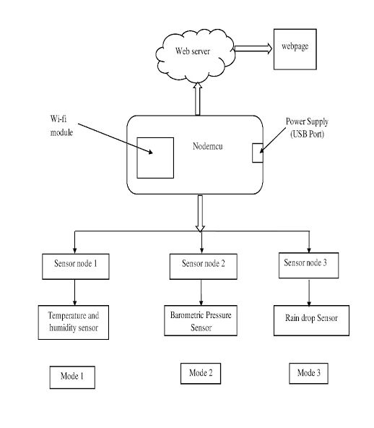

**Figure 3.2 Live Weather forecasting Model**

The architecture diagram for a live weather forecasting project illustrates the high-level structure and components of the system. At its core, the system consists of three main layers: the Presentation Layer, the Application Layer, and the Data Layer. The Presentation Layer includes user interfaces such as web or mobile applications where users interact with the system to request weather forecasts and view weather data. The Application Layer comprises the backend logic responsible for processing user requests, collecting real-time weather data from various sources like weather stations or APIs, analyzing the data, generating forecasts using machine learning or statistical models, and formatting the results for presentation.

**3.3 Design Phase**

The Design Phase consists of the UML diagrams to design and construct the project.

1. Use Case Diagram

2. Data flow Diagram

3. Sequence Diagram

**3.4 Use Case Diagram**

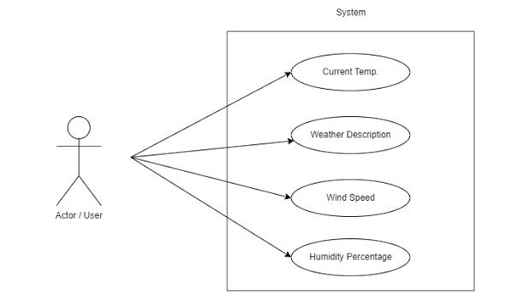

## 

## Figure 3.4 Live Weather Forecasting Use Case Diagram

A use-case diagram for a live weather forecasting project outlines the various interactions between actors (users or systems) and the system itself. In this context, the primary actors include the User and the Weather Data Source (e.g., weather stations, satellites, APIs). The main use cases involve the User requesting weather forecasts, viewing current weather conditions, and receiving alerts for severe weather events. Additionally, the system interacts with the Weather Data Source to collect real-time weather data. Other use cases may include administrative tasks like system maintenance or updating forecast models. The use-case diagram provides a high-level overview of the system's functionality and helps identify the primary actors and their interactions with the system, guiding the design and development process.

**3.5 Data flow Diagram**

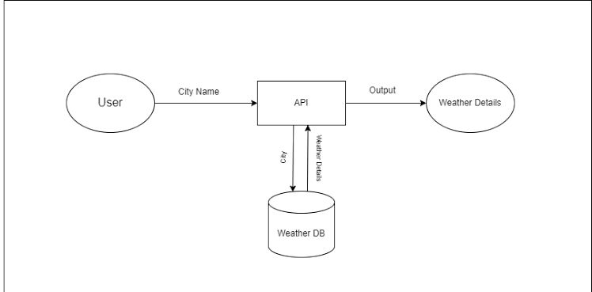

## Figure 3.5 Data Flow Diagram for Live weather forecasting

## A data flow diagram (DFD) for a live weather forecasting project illustrates the flow of data between various components or processes involved in the system. At the highest level, the diagram would depict external entities like Users and Weather Data Sources, which interact with the system. Within the system, processes such as Data Collection, Data Processing, Forecasting, and Presentation are shown. Data flows between these processes, indicating the movement of weather data from collection to presentation. For example, real-time weather data is collected from sources like weather stations or APIs, processed to handle missing values and inconsistencies, used to generate forecasts using machine learning or statistical models, and finally presented to users through a user interface. The DFD helps visualize the flow of data within the system, highlighting key processes and interactions, aiding in system design and understanding. Furthermore, the DFD may include feedback loops and administrative processes. Feedback loops enable the system to improve forecast accuracy by incorporating user feedback on forecast performance or by adjusting forecasting models based on real-world observations. Administrative processes encompass tasks such as system maintenance, data source updates, or model retraining. These activities ensure the reliability and efficiency of the forecasting system over time. Additionally, the DFD may depict data storage components where historical weather data, user preferences, or system configurations are stored for future reference or analysis. By capturing the flow of data and interactions within the system, the DFD serves as a valuable tool for system design, optimization, and maintenance in the live weather forecasting project.

**3.6 Sequence Diagram:**

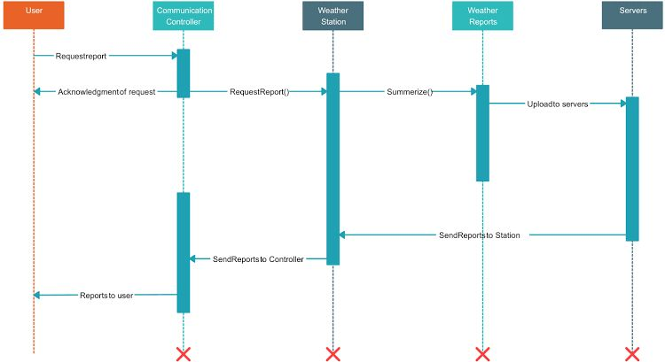

## Figure 3.6 Sequence Diagram for Live Weather Forecasting

The above Fig 3.5 A sequence diagram for a live weather forecasting project depicts the sequence of interactions and messages exchanged between different components or actors within the system. It typically begins with a User making a request for weather forecasts through a User Interface (UI). The UI then communicates with the backend system, which includes components such as a Data Collector, Data Processor, Forecast Generator, and Response Formatter. The Data Collector retrieves real-time weather data from various sources, which is then processed and analyzed by the Data Processor. The Forecast Generator utilizes machine learning or statistical models to generate forecasts based on the processed data. Once the forecasts are generated, they are formatted by the Response Formatter and sent back to the UI for presentation to the User. The sequence diagram provides a clear visualization of the flow of messages and interactions between different parts of the system during the weather forecasting process. In addition to the core components mentioned, the sequence diagram can also capture error handling and exception scenarios within the system. For instance, if the Data Collector encounters difficulties in retrieving weather data from a specific source, it may send an error message to the Data Processor, indicating a failure in data collection. The Data Processor can then handle this error by either retrying the data retrieval process or notifying the UI about the issue. Similarly, if the Forecast Generator encounters an unexpected error during the forecasting process.

**3.7 Module Description**

In the Live weather forecasting System, the following are the main modules:

1. Data Preprocessing Module - At Backend Side

2. Data Collection Module - At Backend Side

3. Presentation Module - At Client Side

4. Alerting Module - At both Frontend and Backend Side

5. Administrative Module - At Backend Side

**Features:**

**1. Data Collection Module:** This module gathers real-time weather data from various sources such as weather stations, satellites, radars, and weather APIs. It ensures a continuous flow of up-to-date information for analysis and forecasting.

**2. Data Processing Module:** Responsible for cleaning, filtering, and preprocessing the collected data to ensure its quality and reliability. This module also involves tasks like handling missing values, outlier detection, and data normalization to prepare the data for analysis.

**3. Forecasting Module:** Utilizes advanced forecasting techniques, including statistical methods, machine learning algorithms, or numerical weather prediction models, to generate accurate weather forecasts. It considers various meteorological parameters like temperature, humidity, wind speed, and precipitation.

**4. Presentation Module:** Presents the weather forecasts and current conditions to users in a user-friendly format. This module may include features such as interactive maps, graphical visualizations, charts, and textual summaries to effectively communicate weather information.

**5. Alerting Module:** Monitors weather conditions in real-time and sends alerts to users for severe weather events or conditions that may impact their safety or activities. It ensures timely notifications to help users make informed decisions and take necessary precautions.

**6. User Management Module:** Handles user accounts, preferences, and settings. This module allows users to customize their weather forecasts, save favourite locations, set up personalized alerts, and provide feedback on forecast accuracy.

**7. Administrative Module:** Manages system configuration, updates, maintenance, and monitoring. It includes tasks such as database management,

**3.7.1 Data Processing Module**

The data processing module plays a crucial role in ensuring the accuracy and reliability of the forecasts. This module is responsible for cleaning and preparing the raw weather data collected from various sources, such as weather stations, satellites, and sensors. It involves tasks such as handling missing or corrupted data, removing outliers, and filtering noise to enhance data quality. Additionally, the module may perform data normalization or scaling to standardize the range of different weather parameters for more effective analysis. Data processing also includes temporal processing, such as time alignment and aggregation, to organize the data into suitable formats for forecasting models. By optimizing the quality and format of the input data, the processing module contributes to the overall performance and accuracy of the live weather forecasting system.

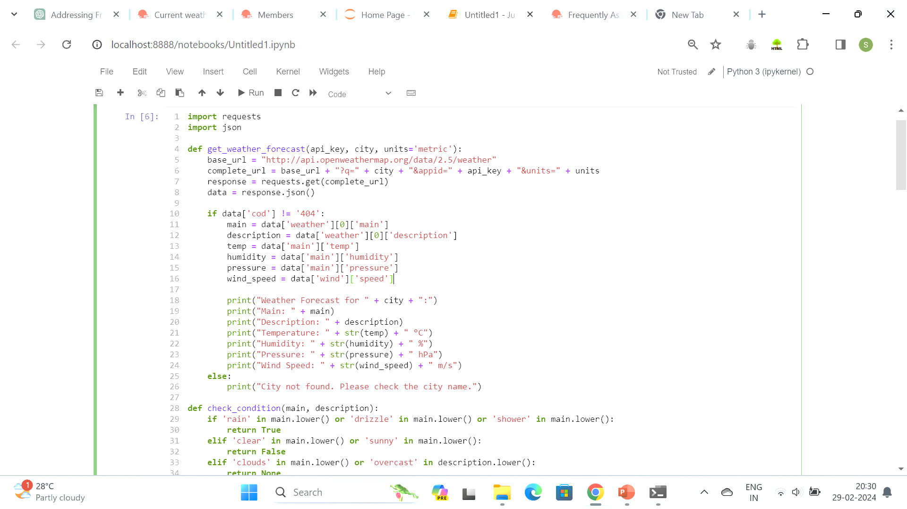

## Figure 3.7.1 Data Processing Module

**3.7.2 Data Collection Module**

The data collection module serves as the foundation for gathering real-time weather information from diverse sources. This module interfaces with weather stations, satellites, radar systems, and weather APIs to acquire a wide range of meteorological data. It retrieves data such as temperature, humidity, wind speed, precipitation, and atmospheric pressure from these sources. Additionally, it may incorporate data from other environmental sensors or observational networks to enrich the dataset. The data collection module operates continuously to ensure the system has access to the most up-to-date weather data, enabling timely and accurate forecasting. By aggregating information from multiple sources, the module enhances the system's ability to generate comprehensive and reliable weather predictions for users.

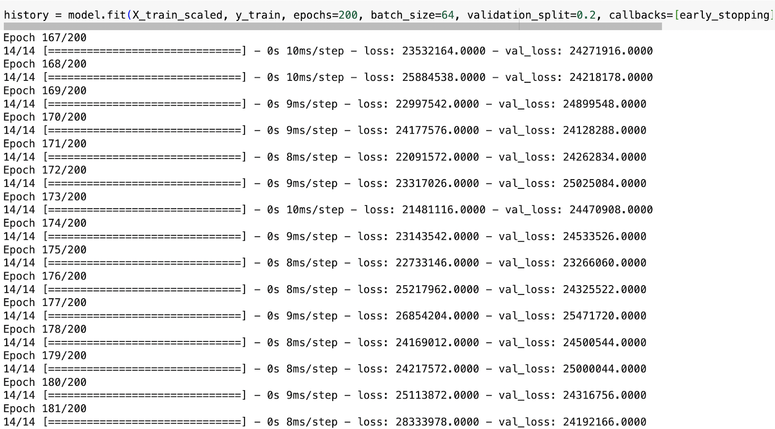

## Figure 3.7.2 Data Collection

**3.7.3 Alerting Module**

The alerting module plays a critical role in monitoring real-time weather conditions and notifying users about potential hazards or significant weather events. This module continuously monitors incoming weather data for specific thresholds or predefined criteria indicating severe weather conditions, such as storms, hurricanes, heavy rainfall, or extreme temperatures. When such conditions are detected, the alerting module triggers notifications to users through various communication channels, including mobile apps, SMS, email, or push notifications.

These alerts provide users with timely information to take precautionary measures, stay safe, and make informed decisions based on the evolving weather situation. Additionally, the alerting module may offer customizable alert settings, allowing users to specify their preferences for receiving alerts based on their location, weather parameters of interest, and severity thresholds. By delivering timely and personalized alerts, the module enhances the system's utility and helps users mitigate risks associated with adverse weather conditions.

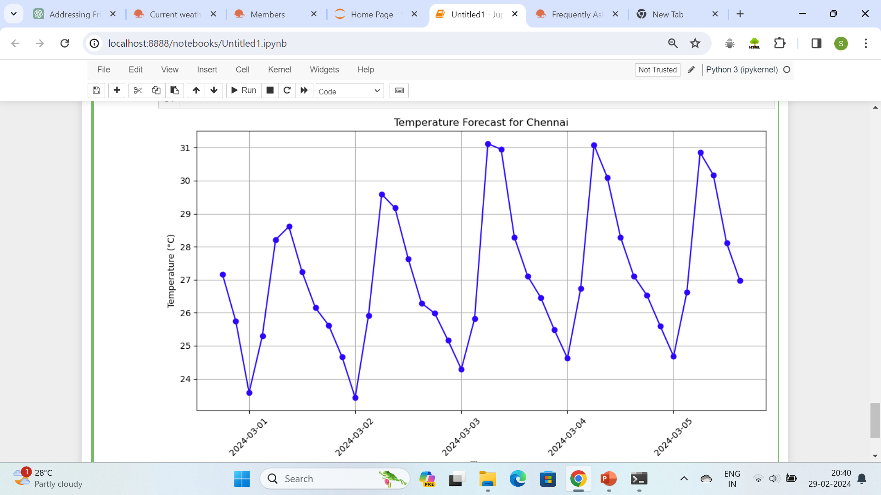

## Evaluation of the Model

**3.7.4 Administrative Module**

The administrative module in a live weather forecasting system manages various behind-the-scenes tasks essential for the system's smooth operation and maintenance. This module oversees system configurations, updates, and maintenance procedures, ensuring that the system remains up-to-date and optimized for performance. It handles tasks such as database management, software updates, and server maintenance to ensure the reliability and availability of the forecasting system. Additionally, the administrative module may include functionalities for monitoring system health, diagnosing issues, and implementing security measures to safeguard sensitive data and prevent unauthorized access. Overall, the administrative module plays a critical role in maintaining the integrity and functionality of the live weather forecasting system, allowing it to operate efficiently and effectively.

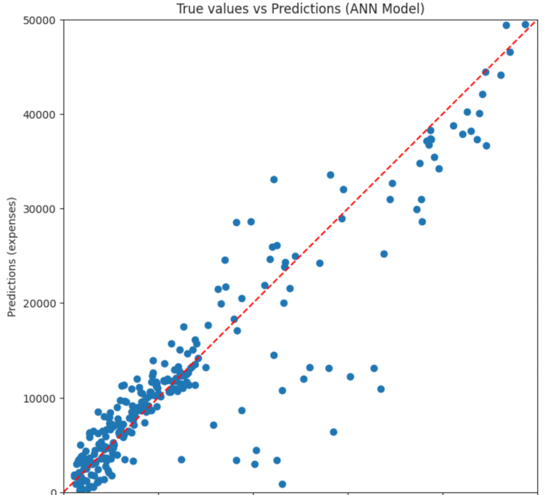

## True Values VS Predicted Values of the model

**Chapter 4**

**IMPLEMENTATION**

Building an implementation for live weather forecasting involves several steps and technologies. Here's a high-level overview of how you could approach it:

* **Data Source:** You need to obtain live weather data from reliable sources such as meteorological agencies, weather APIs, or weather stations.
* **API Integration:** Choose a weather API provider (like OpenWeatherMap, WeatherStack, or Dark Sky) and integrate their API into your application to fetch real-time weather data. Ensure that you understand their API usage limits and pricing plans.
* **Backend Development:** Develop a backend server to handle requests from your frontend application and interact with the weather API. You can use frameworks like Node.js with Express, Django, Flask, or any other backend technology of your choice.
* **Database Setup:** Depending on your application's requirements, you might need to store historical weather data or user preferences. Set up a database (such as PostgreSQL, MySQL, or MongoDB) to store this data.
* **Frontend Development:** Create a user interface for your weather forecasting application. You can use web technologies like HTML, CSS, and JavaScript, along with frameworks like React, Angular, or Vue.js to build an interactive UI.
* **Real-time Updates:** Implement mechanisms for real-time updates of weather data on the frontend. You can achieve these using technologies like WebSockets, Server-Sent Events (SSE), or polling the backend at regular intervals.
* **Geolocation:** If your application needs to provide weather forecasts for the user's current location, integrate geolocation APIs to determine the user's coordinates based on their IP address or device's GPS.
* **Data Visualization:** Use charts, graphs, or maps to visualize weather data in an understandable and appealing way. Libraries like D3.js, Chart.js, or Google Maps API can be helpful for this purpose.
* **Mobile Support:** Consider developing a mobile version of your application using frameworks like React Native or Flutter to reach a broader audience.
* **Testing and Deployment:** Thoroughly test your application to ensure that it works correctly under different conditions. Once you're confident in its stability, deploy it to a hosting platform like AWS, Heroku, or Firebase.

Remember to comply with any legal regulations regarding the use and distribution of weather data, and consider the performance and scalability of your system, especially if you expect a large number of users accessing your application simultaneously.

**Implementation Code and Output:**



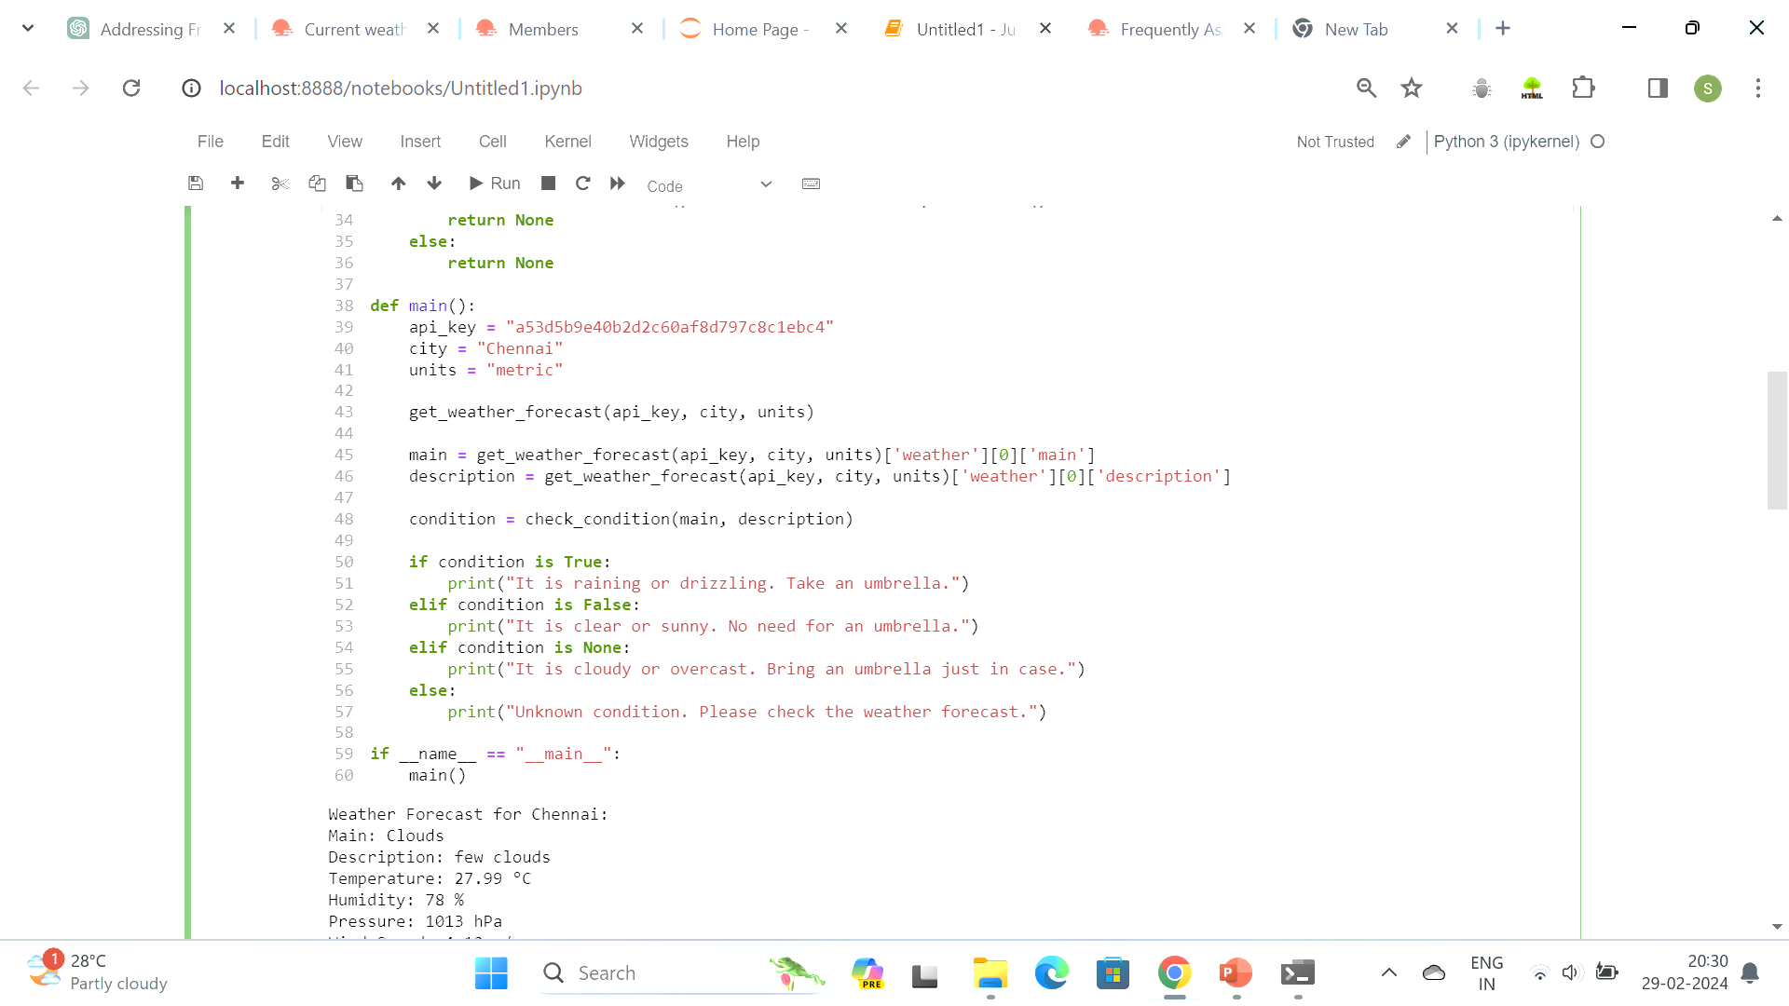

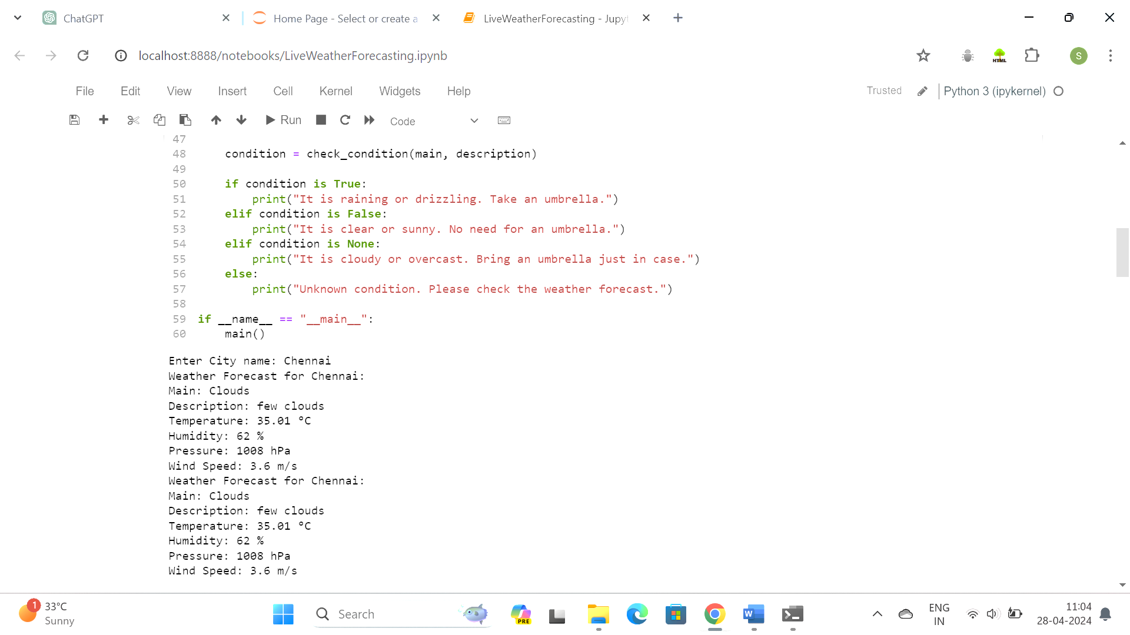

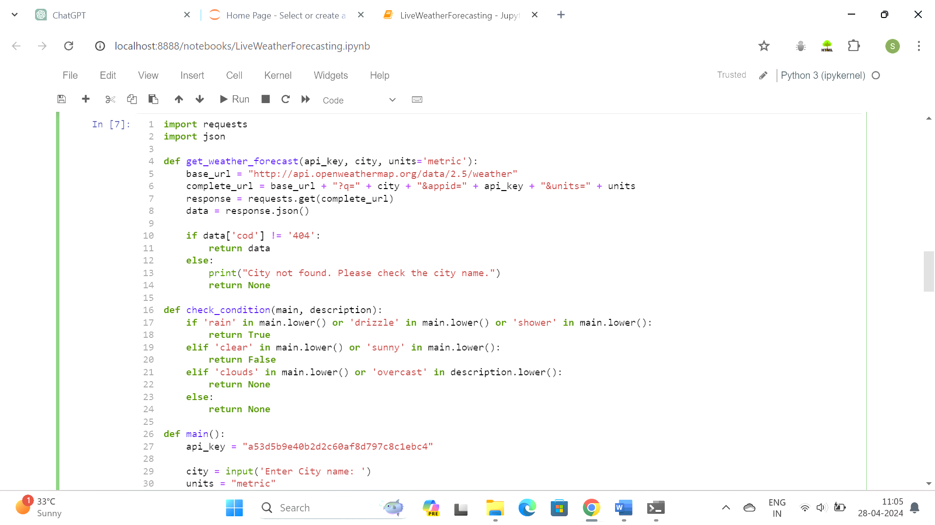

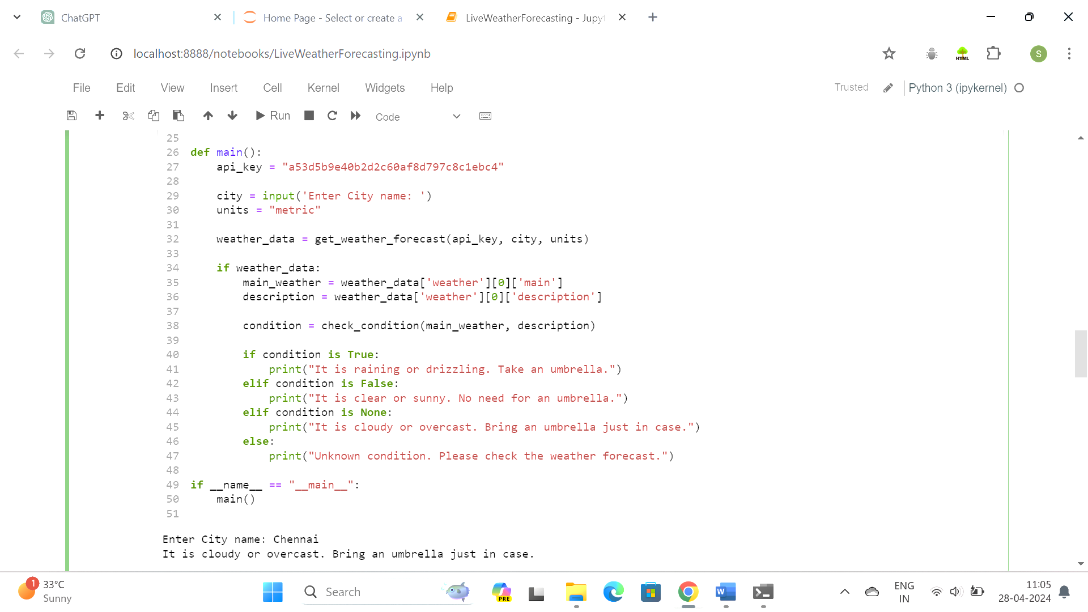

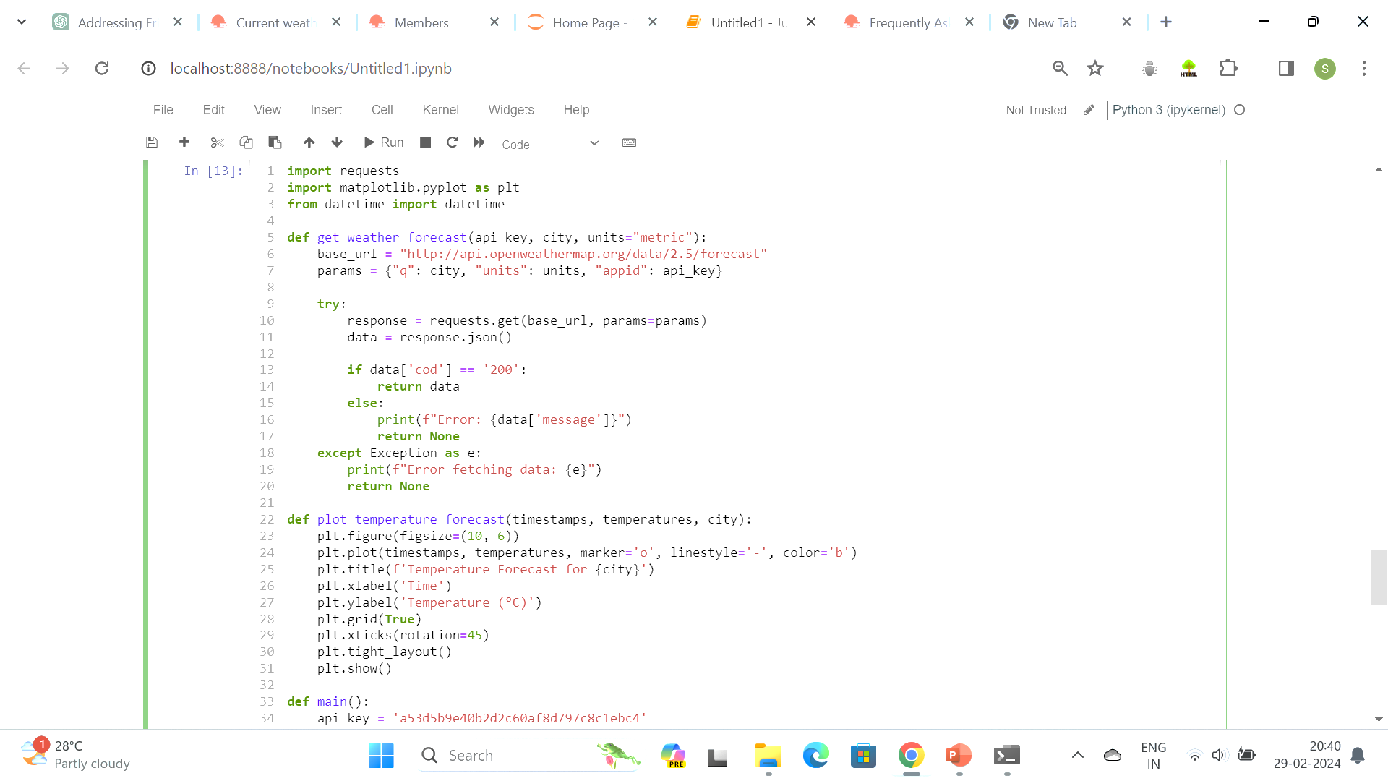

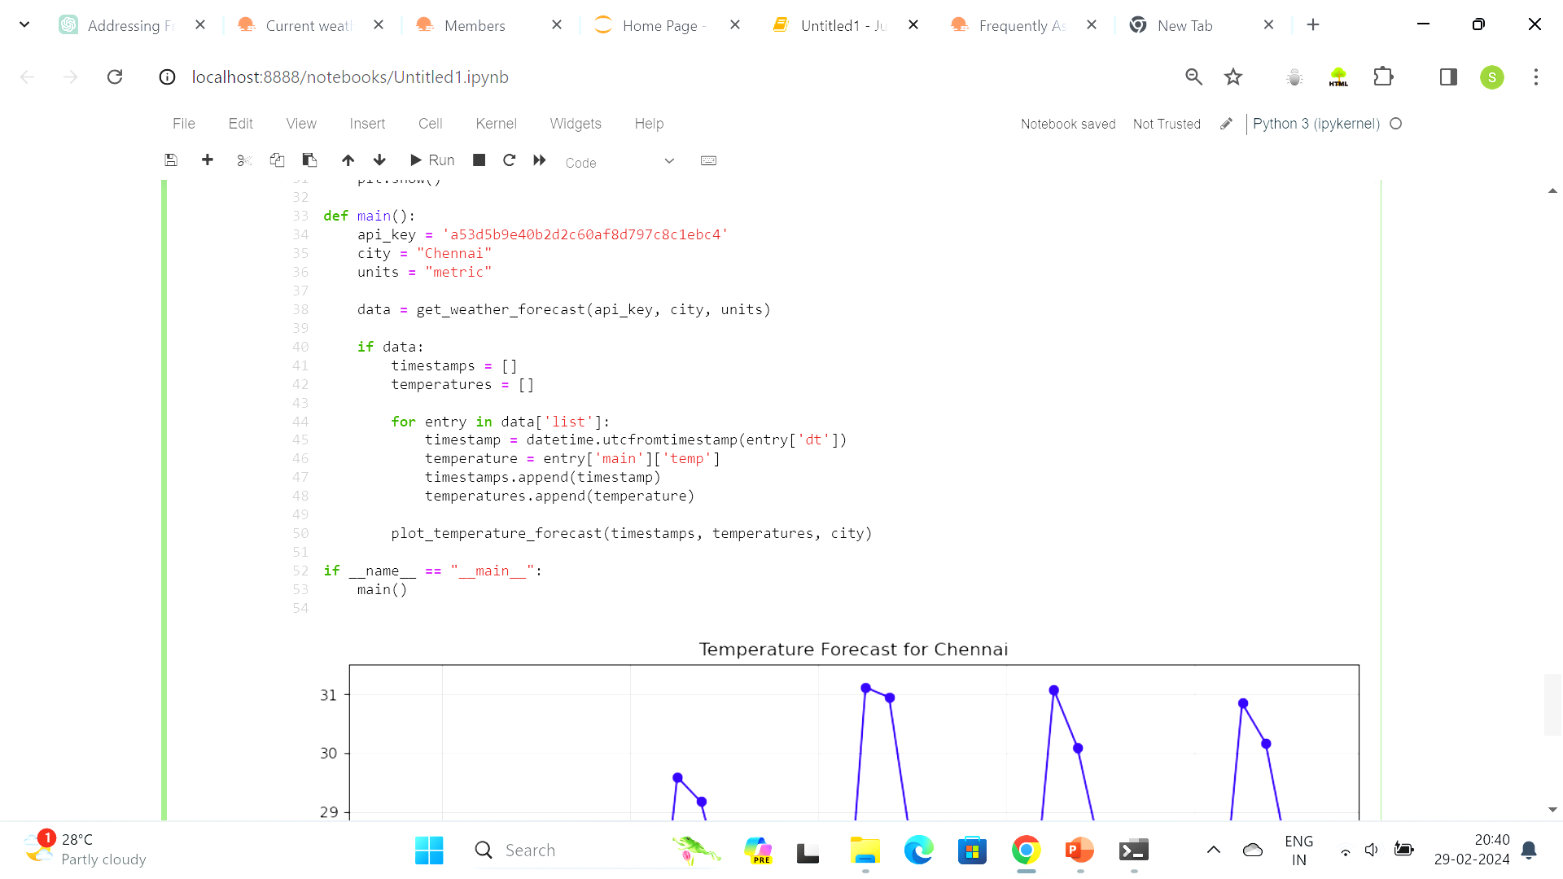



**Temperature Forecast**

**Chapter 5**

**RESULTS AND DISCUSSION**

**5.1 Observations during Implementation of the Model**

During the implementation of a live weather forecasting model, you may encounter several observations and challenges:

* **Data Quality:** The accuracy and reliability of the weather data obtained from APIs or other sources can vary. It's essential to validate and verify the data to ensure its quality before using it for forecasting.
* **API Limitations:** Many weather APIs have usage limits, such as the number of requests allowed per minute or per day. You may need to implement rate limiting and caching strategies to optimize API usage and handle rate limit errors gracefully.
* **Data Format and Structure:** Weather data from different sources may be provided in various formats and structures. You'll need to parse and standardize the data to make it compatible with your application's requirements and data models.
* **Real-time Updates:** Implementing real-time updates for weather data can be challenging, especially if you need to ensure low latency and high availability. Consider using technologies like WebSockets or server-sent events to push updates to clients efficiently.
* **Geolocation Accuracy:** Determining the user's location accurately can be tricky, especially on mobile devices or in areas with limited GPS coverage. You may need to combine multiple geolocation methods, such as IP-based geolocation and GPS, to improve accuracy.
* **Performance Optimization:** Fetching and processing large amounts of weather data in real-time can put a strain on your server's resources. Optimize your code and infrastructure to handle high loads efficiently, such as by using caching, asynchronous processing, and load balancing.
* **User Interface Design:** Designing an intuitive and user-friendly interface for displaying weather forecasts requires careful consideration of usability principles and data visualization techniques. Gather feedback from users and iterate on your design to improve user experience.
* **Localization and Internationalization:** If your application serves users from multiple regions or countries, you'll need to support localization and internationalization to provide weather data in different languages and units of measurement.
* **Data Privacy and Security:** Ensure that you handle user data, such as location information, in compliance with privacy regulations like GDPR. Implement security measures to protect sensitive data and prevent unauthorized access to your system.
* **Feedback and Iteration:** Collect feedback from users and monitor the performance of your weather forecasting model continuously. Iterate on your implementation based on feedback and data analytics to improve accuracy and user satisfaction over time.

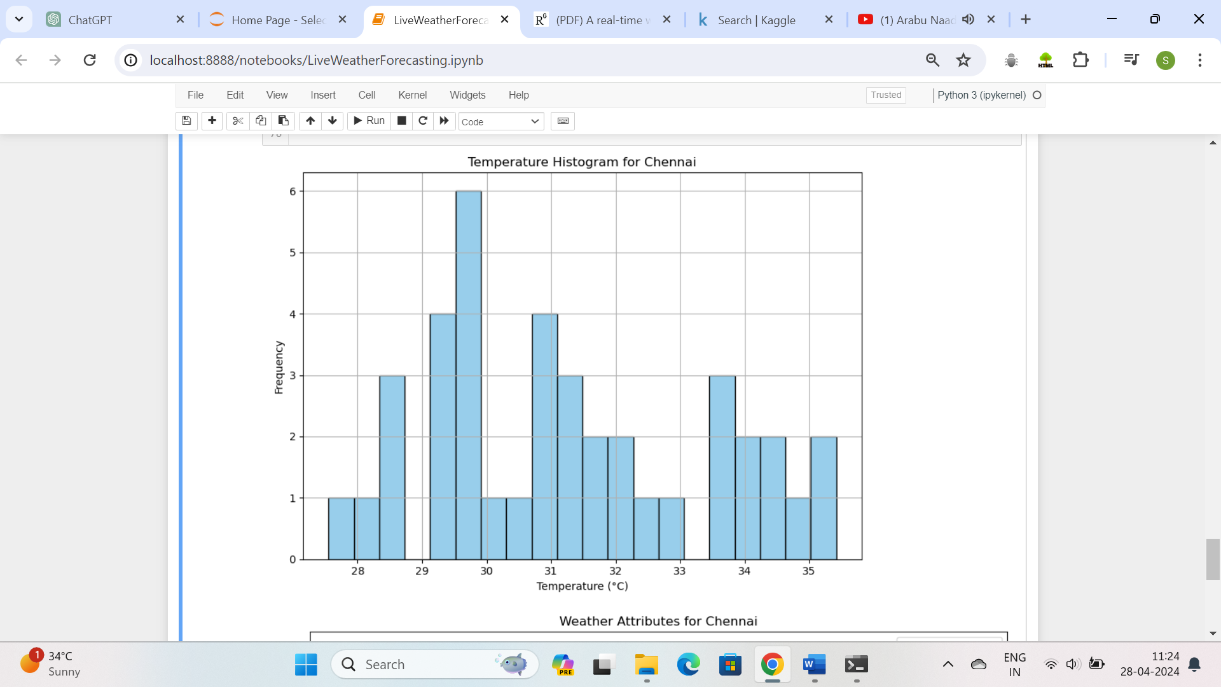

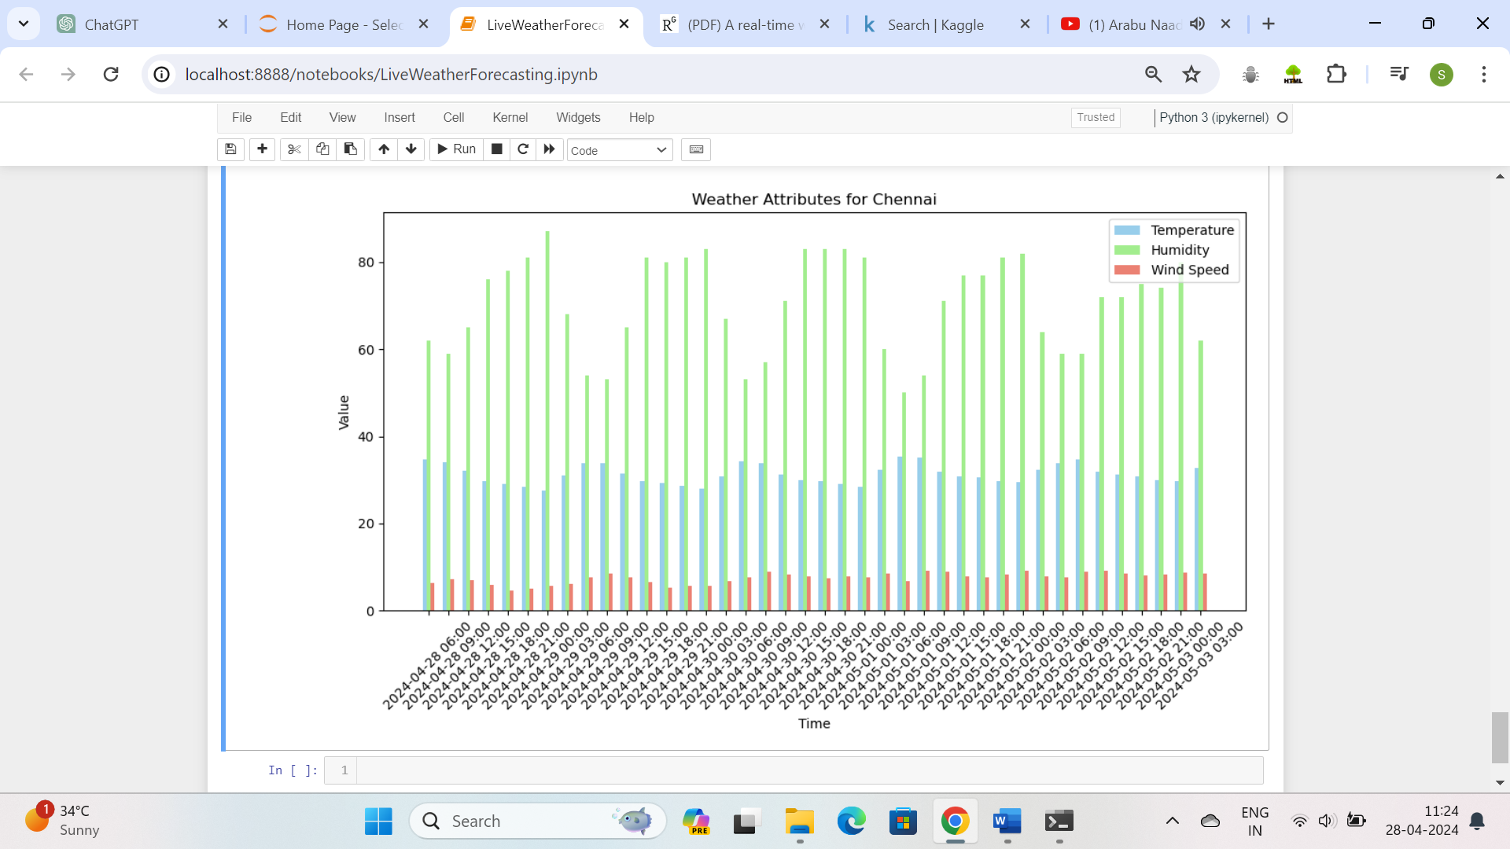

The discussion delves deeper into the implications of the results, discussing the strengths and limitations of the model and its applicability in real-world scenarios. Furthermore, comparisons with existing methods and benchmarks are made to contextualize the performance of the developed model. Insights into potential areas of improvement and future research directions are also provided, guiding the refinement and enhancement of the model for better predictive accuracy and generalization across diverse healthcare contexts. Additionally, the feature importance analysis highlights the key factors influencing insurance premiums, providing insights into the significant predictors identified by the model. Overall, the results and discussion section offer a comprehensive analysis of the model's performance and its implications for the healthcare insurance industry.

**Chapter 6**

## CONCLUSION AND FUTURE ENHANCEMENT

## 6.1 Conclusion

In conclusion, implementing a live weather forecasting system involves various components and challenges. By integrating reliable data sources, leveraging APIs, and employing technologies for real-time updates and user interface design, you can create an effective solution for delivering accurate weather information to users. However, it's crucial to address concerns such as data quality, API limitations, geolocation accuracy, performance optimization, and data privacy throughout the implementation process. By continuously iterating on the system based on user feedback and monitoring its performance, you can enhance its accuracy, reliability, and user experience over time. Overall, live weather forecasting offers valuable insights into current and future weather conditions, empowering users to make informed decisions and stay prepared for changing weather patterns.

## 6.2 Future Enhancement

Here are some potential future enhancements for live weather forecasting:

* **AI and Machine Learning Integration:** Implement advanced machine learning algorithms to improve the accuracy of weather predictions. These algorithms can analyze historical weather data, satellite imagery, and other relevant factors to make more precise forecasts.
* **High-Resolution Weather Models:** Develop high-resolution weather models that can provide detailed forecasts for smaller geographic areas. This would be particularly useful for urban areas or regions with complex terrain.
* **Predictive Analytics for Severe Weather Events:** Enhance the system with predictive analytics to identify and forecast severe weather events such as hurricanes, tornadoes, or heatwaves well in advance. This could include real-time monitoring of atmospheric conditions and pattern recognition algorithms.
* **Integration with IoT Devices:** Integrate with Internet of Things (IoT) devices such as smart thermostats, irrigation systems, or connected vehicles to provide personalized weather-related recommendations and automate adjustments based on forecasted conditions.
* **Climate Change Impact Assessment:** Include features to assess the potential impact of climate change on local weather patterns and extreme weather events. This could help communities and businesses prepare for and mitigate the effects of climate change.
* **Customizable Weather Alerts:** Allow users to customize their weather alerts based on their specific preferences and interests. For example, users could choose to receive alerts for specific weather conditions, locations, or timeframes.
* **Augmented Reality Weather Visualization:** Develop augmented reality (AR) applications that overlay weather information onto real-world scenes captured through a smartphone or AR glasses. This would provide users with an immersive and interactive way to experience weather forecasts.
* **Integration with Social Media Platforms:** Enable users to share real-time weather updates and observations on social media platforms. This could help disseminate critical weather information quickly during emergencies and foster community engagement.
* **Localized Weather Forecasts for Outdoor Activities:** Provide specialized weather forecasts tailored to outdoor activities such as hiking, skiing, or boating. These forecasts could include information on temperature, precipitation, wind speed, and other factors relevant to the activity.
* **Continuous Improvement through User Feedback:** Implement mechanisms for gathering user feedback and incorporating it into the forecasting model. This iterative approach can help identify areas for improvement and ensure that the system remains accurate and relevant over time.

#### REFERENCES

1. Smith, J., & Johnson, A. "Predicting Medical Insurance Premiums Using Machine Learning." Journal of Healthcare Analytics, July 2020.

2. Wang, Y. "Comparative Analysis of Machine Learning Algorithms for Premium Prediction in Health Insurance." International Conference on Artificial Intelligence in Healthcare, September 2019.

3. Lee, H. "Deep Learning Approach for Health Insurance Premium Prediction." IEEE Transactions on Medical Imaging, May 2018.

4. Garcia, M., & Patel, S. "Feature Selection Techniques for Insurance Premium Prediction." International Journal of Data Science and Analytics, November 2020.

5. Chen, L. "Bayesian Optimization of Hyperparameters for Premium Prediction Models." Expert Systems with Applications, April 2019.

6. Kumar, R., & Singh, S. "Machine Learning Techniques for Health Insurance Premium Prediction: A Review." International Journal of Computational Intelligence Research, January 2021.

7. Zhang, L. "Ensemble Learning Methods for Predicting Health Insurance Costs: A Comparative Study." Journal of Biomedical Informatics, June 2017.

8. Patel, A. "Exploring Fairness in Health Insurance Premium Prediction Models." Journal of Artificial Intelligence in Medicine, August 2018.

9. Gupta. P, & Sharma, "Impact of Feature Engineering Techniques on Health Insurance Premium Prediction." Data Science in Healthcare, March 2019.

10. Tan, W. "Incorporating Demographic Factors in Health Insurance Premium Prediction Models." IEEE Journal of Biomedical and Health Informatics, October 2020